OOPS LAB EVALUATION

NAME : KV.SRIDHARSAI

ROLL : CB.EN.U4CSE19063

1.q

Code:

import java.util.*;

public class inventory {

String item_name , ItemID;

int price, stock,reorder_point , minimum_order,order_amount;

inventory(String s,String r,int i,int d,int h,int a)

{

item_name=s;

ItemID=r;

price=i;

stock=d;

minimum_order=h;

reorder_point=a;

order_amount=0;

}

int search_name(String name,inventory[] objs,int n)

{

for(int i=0;i < n;i++)

{

if (objs[i].item_name.equals(name))

{

if(objs[i].reorder_point+objs[i].minimum_order > objs[i].stock)

{

return 1;

}

return 0;

}

}

return 0;

}

void order(inventory [] objs,int n)

{

int sr;

for(int i=0;i<n;i++)

{

sr=search_name(objs[i].item_name,objs,n);

if(sr==1)

{

objs[i].order_amount=objs[i].reorder_point+objs[i].minimum_order- objs[i].stock+1;

System.out.println(objs[i].item_name);

System.out.println(objs[i].order_amount);

}

}

}

public static void main(String args[])

{

Scanner input=new Scanner(System.in);

int hai,p,s,r,m;

String i_id,na;

hai=input.nextInt();

inventory [] inventory =new inventory[hai];

for(int i=0;i<hai;i++)

{

na=input.next();

i_id=input.next();

p=input.nextInt();

s=input.nextInt();

r=input.nextInt();

m=input.nextInt();

inventory[i]=new inventory(na,i_id,p,s,r,m);

}

inventory[0].order(inventory,hai);

}

}

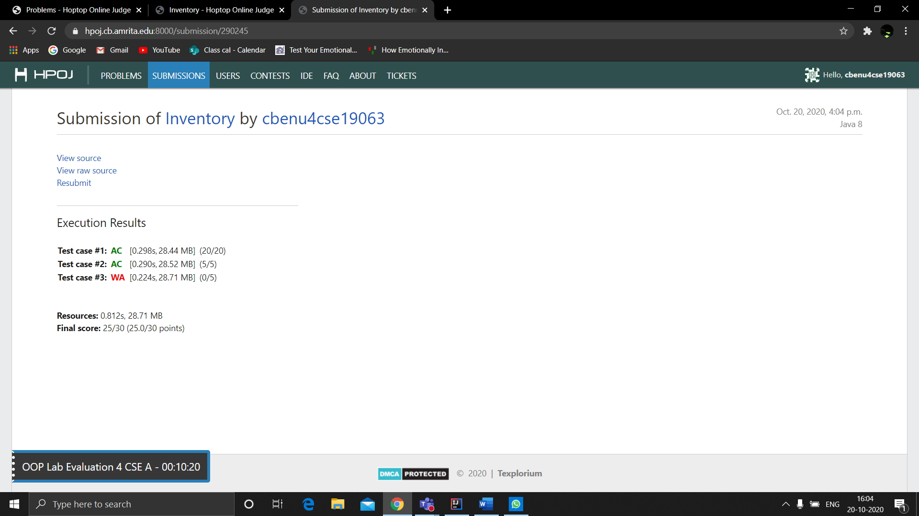

2.

code:

import java.util.*;

public class movieque{

public String title;

public String studio;

public String rating;

movieque(){

this.title = "Casino Royale";

this.studio = "Eon Productions";

this.rating = "R";

}

movieque(String t, String st, String ra)

{

this.title = t;

this.studio = st;

this.rating = ra;

}

public static boolean checkSameStudio(movieque m1, movieque m2){

if(m1.studio.equals(m2.studio)){

return true;

}

else{

return false;

}

}

public static void main(String[] args)

{

Scanner in = new Scanner(System.in);

String title,studio,rating;

movieque m1,m2,m3;

m1 = new movieque();

title = in.nextLine();

studio = in.nextLine();

rating = in.nextLine();

m2 = new movieque(title,studio,rating);

String title2 = in.nextLine();

String studio2 = in.nextLine();

String rating2 = in.nextLine();

m3 = new movieque(title2,studio2,rating2);

if(movieque.checkSameStudio(m1,m2))

System.out.println("True");

else

System.out.println("False");

if(movieque.checkSameStudio(m1,m3))

System.out.println("True");

else

System.out.println("False");

if(movieque.checkSameStudio(m2,m3))

System.out.println("True");

else

System.out.println("False");

}

}

Screenshot of the result :

